**96% - Great job!**

**This hands-on test is an individual assessment meaning you may not get assistance from your instructor or other classmates. You may use your textbook, labs and lecture notes.**

**All code submitted must be your original work. Code must be committed and pushed to your git repository inside the HOT1 folder to receive credit.**

Implement both exercises in one Visual Studio project with links between 2 pages. **-10pts**

**HomeController and Layout file are optional for this test only.**

**DistanceConverter**

Write a program that converts distances between inches and centimeters.

* Prompt the user for a distance in inches.
* When the user submits the form, display the distance in both inches and centimeters as follows:

“2.00 inches is 5.08 centimeters”

* **See rubric on next page for more details.**

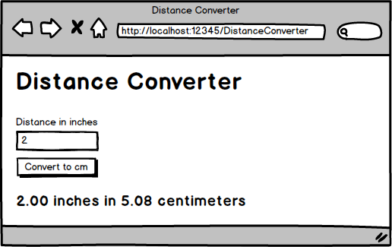

## **DistanceConverter Rubric [40 pts]**

### **Model & Validation [10 pts]**

* **Model Creation:** A model is created and used for the page.
* **Required Field & Validation:** The distance field is required, must be between 1 and 500, and has a custom validation message.

### **Controller & Logic [9 pts]**

* **Action Method Attributes:** The [HttpGet] and [HttpPost] attributes are correctly applied to the action methods.
* **Model Validation Check:** The POST action method checks if the model is valid before doing any calculations.
* **Correct Conversion:** The POST action method correctly converts inches to centimeters.

### **View & Formatting [5 pts]**

* **Error Message Display:** Correct error messages are displayed in red only when appropriate.

### **Bootstrap Styling [16 pts]**

* **Bootstrap Integration -2pts 5.3 is latest:** The latest version of Bootstrap is implemented.
* A screen shot of a computer

  AI-generated content may be incorrect.
* **Stylesheet:** The Bootstrap stylesheet is included using libman.
* **Navbar:** A collapsible Bootstrap Navbar is implemented.
* **Floating Labels:** Floating labels are used to associate text boxes with their labels.
* **Input Styling:** The form-control class is applied to input boxes.
* **Error Message Styling:** The text-danger class is applied to error messages to make them red.
* **Button Styling:** The btn and btn-primary classes are applied to the button.
* **Margins:** Margins are used to make the form look more professional.

**OrderForm**

Create a program for ordering T-Shirts.

* Users must enter a quantity.
* Users can enter an **optional** discount code.
* Shirts are normally $15 each. Sales tax is 8%.
* If the discount code is valid, then apply the relevant discount.
* If the discount code is not valid, then display an error message and calculate the receipt without a discount
* **See rubric on next page for more details.**

|  |  |
| --- | --- |
| **Discount Code** | **Discount Percentage** |
| 6175 | 30% off |
| 1390 | 20% off |
| BB88 | 10% off |

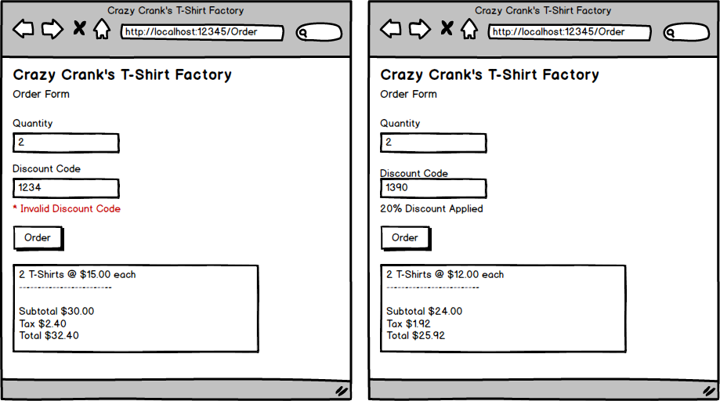

## **OrderForm Rubric [50 pts]**

### **Model & Validation [9 pts]**

* **Model Creation:** A model class is created and used.
* **Required Field & Validation:** The quantity field is required and has a custom error message.
* **Error Message Display:** The view displays the custom validation message from the model.

### **Controller & Logic [21 pts]**

* **Correct Calculations:** Subtotal, tax, and total are calculated correctly.
  + The base cost for each shirt is $15.
  + Sales tax is 8%.
* **Discount Application:** A valid discount code is correctly applied to the shirt cost.
  + 6175 is a 30% discount.
  + 1390 is a 20% discount.
  + BB88 is a 10% discount.
* **Error Handling:** An error message is displayed if the discount code is not valid, and the receipt is calculated without a discount.

### **View & Formatting [8 pts]**

* **Error Message Display:** Error messages are displayed in red only when appropriate.
* **Monetary Formatting:** All monetary amounts are formatted as currency (e.g., $15.00).

### **Bootstrap Styling [12 pts]**

* **Bootstrap Integration -2pts:** The latest version of Bootstrap is implemented.
* **Navbar:** A collapsible Bootstrap Navbar is implemented.
* **Floating Labels:** Floating labels are used to associate text boxes with their labels.
* **Form Controls:** Bootstrap classes are applied to all form controls
* **Button Styling:** Bootstrap classes are applied to the button.
* **Margins:** Margins are used to make the form look more professional.